**What does this technology accomplish for you?**

React.js is an easy to use open-source JavaScript library used to create user interfaces. You are able to design each individual state in your program and React will render the appropriate material for you quickly and efficiently. It’s also compatible with any backend. The API is well defined to allow a simple flow of data from your frontend to backend, and vice-versa.

**How does this technology accomplish what it does?**

Each tagged element in HTML is represented as a Virtual DOM object in ReactJS. Virtual DOM is a JS object that mimics the browser’s DOM, but is highly optimized compared to the browser’s DOM. The Virtual DOM is represented as a ReactElement, seen in the source code below.

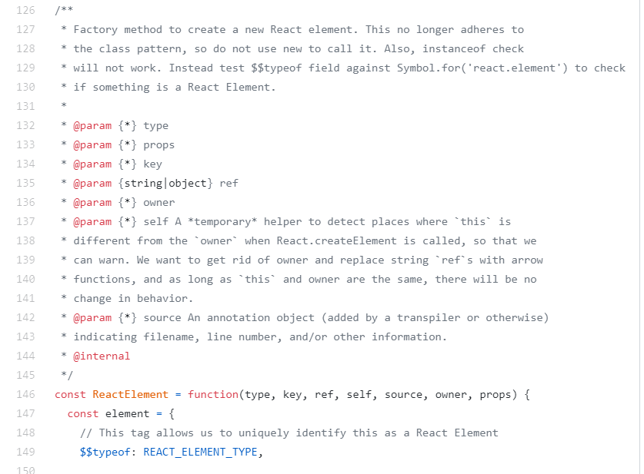

Link: <https://github.com/facebook/react/blob/3b3decf87121dcc20bfc0820b7b35d2b028adaf2/packages/react/src/ReactElement.js>

Diffing algorithm:

You have a DOM when the website loads. You click something, and a new DOM is generated. How does it know what to change? And how does it do it efficiently? It uses the React diffing algorithm.

This algorithm puts each tag into a tree. Each node is a ReactElement seen above. Different tags have different trees i.e. <a> and <p> will have separate trees. Any change to a tag will lead to a complete rebuild of its subtree.

Optimizations are included to ensure fast and efficient updates to each object. The algorithm can be found in the ReactNativeAttributePayload.js file.

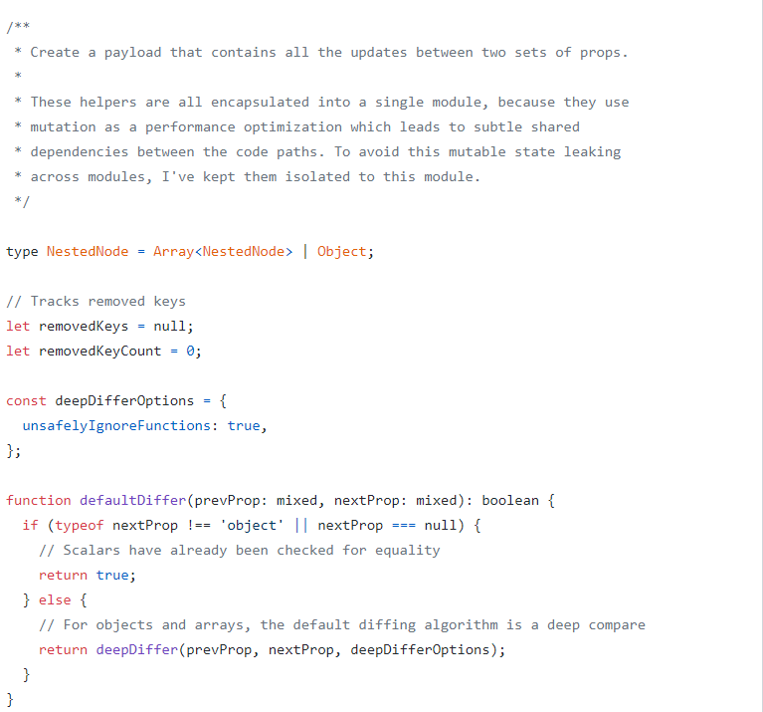

Link: <https://github.com/facebook/react/blob/38dd17ab98ce288fd0d0b68682a6df0f0a49e158/packages/react-native-renderer/src/ReactNativeAttributePayload.js>

**What licenses or terms of service apply to this technology?**

React uses the MIT license. This means that there are very limited restrictions in reusing the software. The only requirement associated with an MIT license is that you include the MIT copyright notice with any copies of the software. You may use the software for commercial use and may sell the software.